Scratch tips:
Website: scratch.mit.edu
There are tutorials on scratch that will help with basic functions. The game is set up on an xy-axis.
If you want to make the character move with certain keys, you have to make sure you use the correct axis – x is left/right and y is up/down.
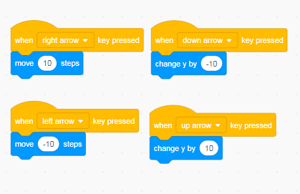 Jump: 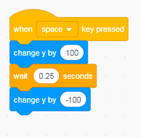

If you want them to have lives/score/timer – you have to create a variable.
This is setting up so that I started with 3 lives and any time my character touched another character or black on my screen, he lost a life. 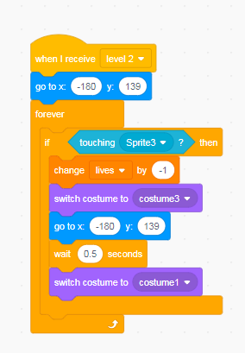 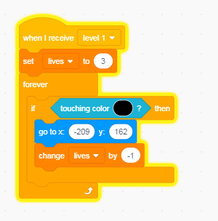

To change levels, the easiest way is to have a sprite to reach and when you reach that sprite, you use the broadcast code. Just make sure after you send out the broadcast code, you tell all your components what to do when they get that code.
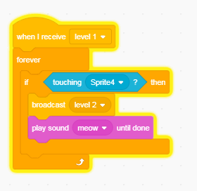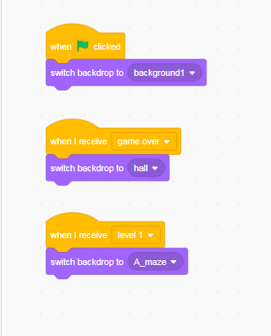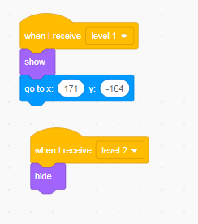

** You just have to remember that everything you want to do in the game, you have to code to make it happen.

Website requirements:
He will need to create a website with a heading, a paragraph about himself or something important to him, and include two pictures.
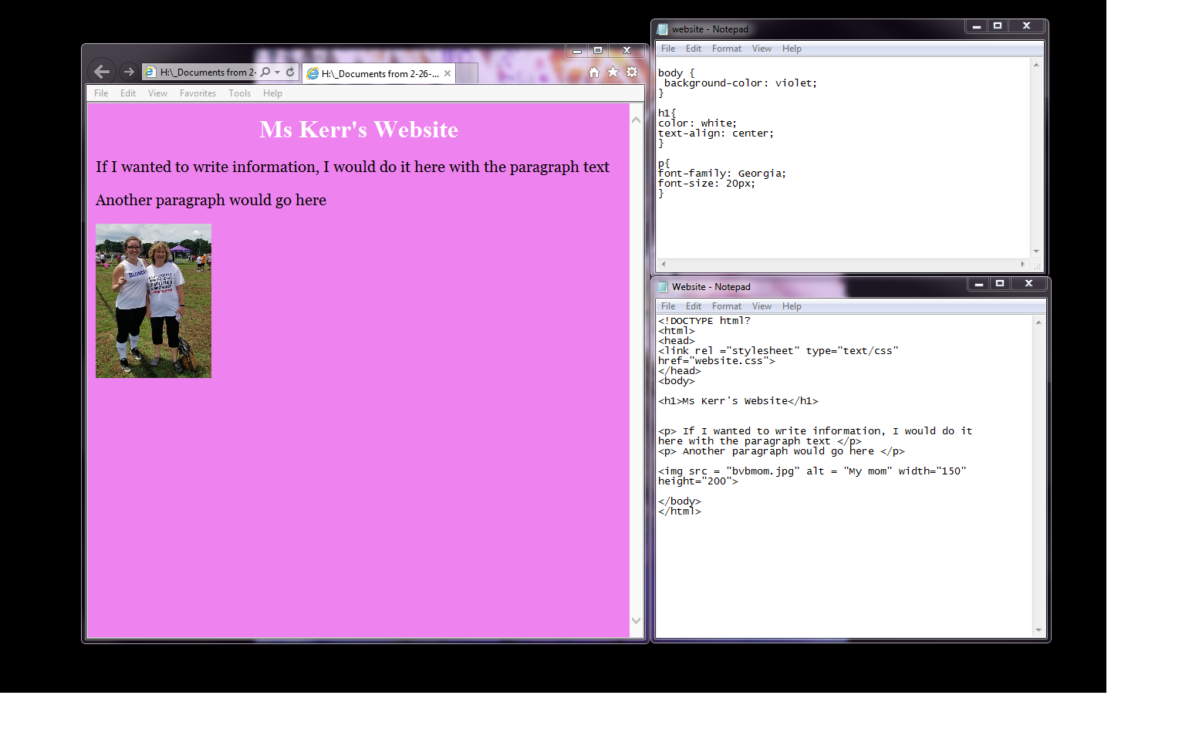
To start – open notepad (you will need two files at the end)
In one notepad file, you will code the basics of the webpage. The top few lines on my code are the same as Zachary will need on his – it will just need to reflect his name, not mine. Then write the paragraph and add two images.
When he saves – it needs to be saved as website.html or it won’t open correctly. To view his page, open the documents folder and open website.html. It should open in the internet.
The other notepad is the CSS file. This file will change all the font, colors, etc for the website.
When he saves this he needs to save it as website.css so it will work with the html file.
The website w3schools will have all of the code and tips and tutorials he will need for this project!

